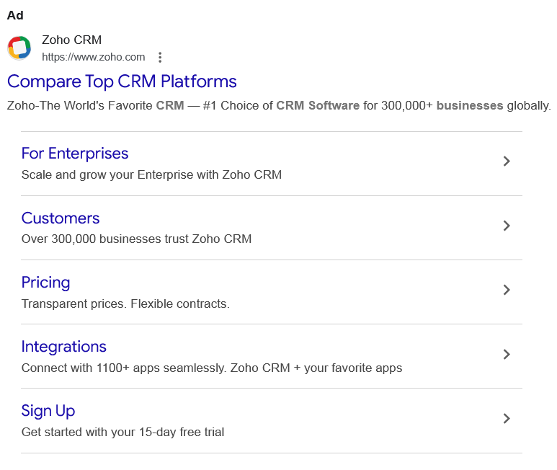
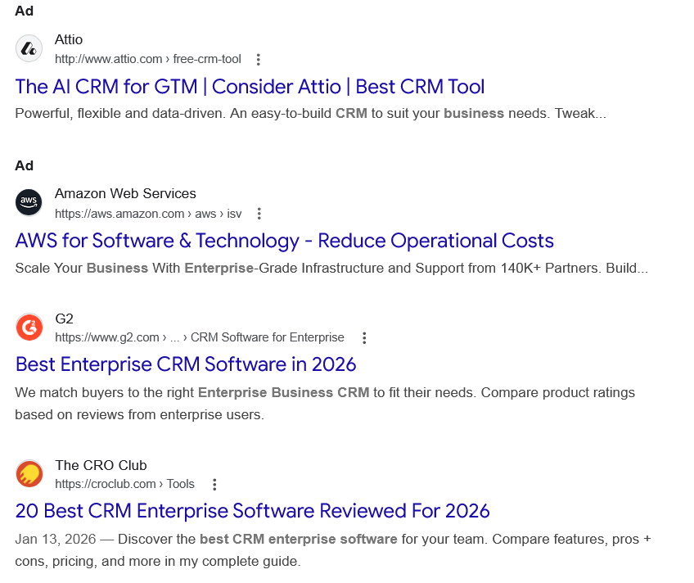
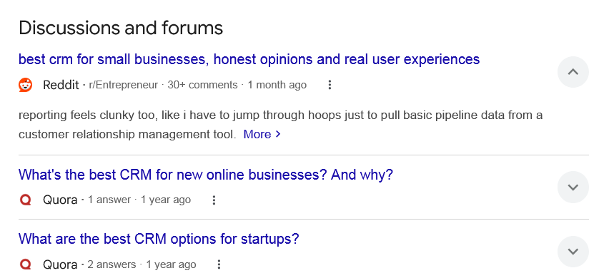
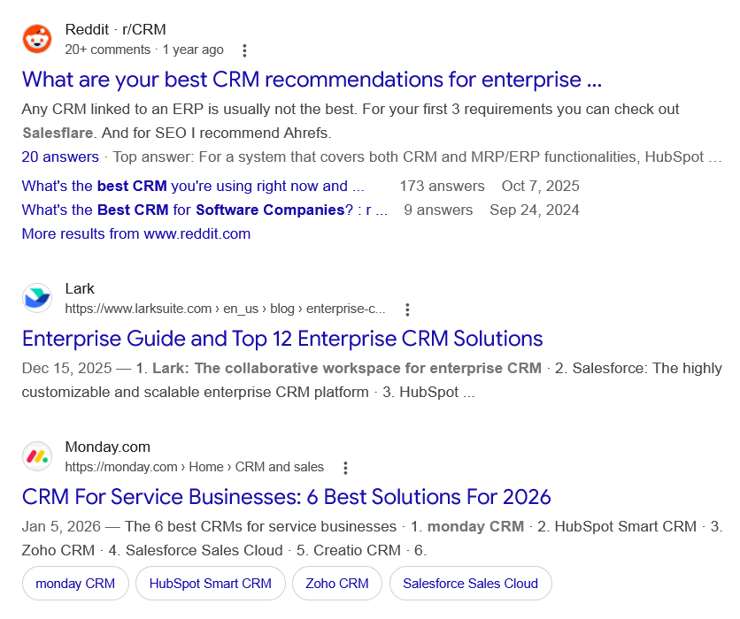
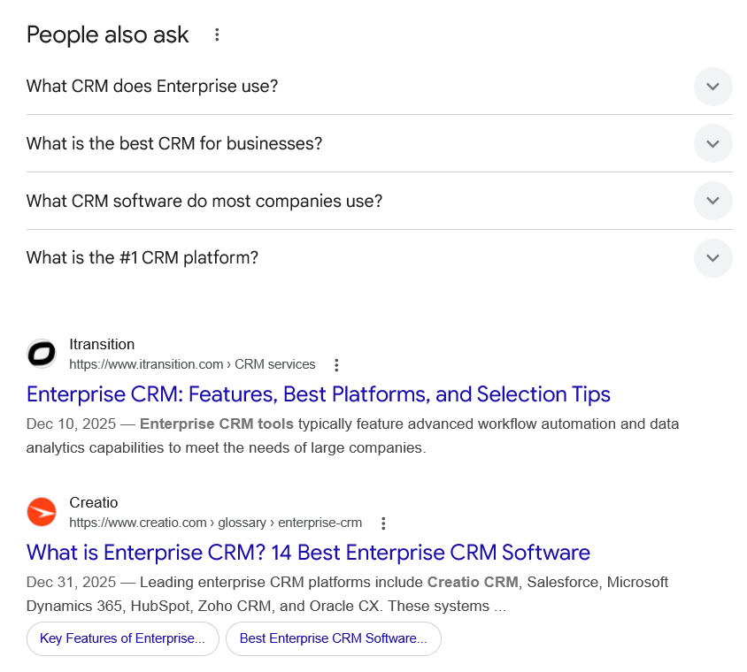
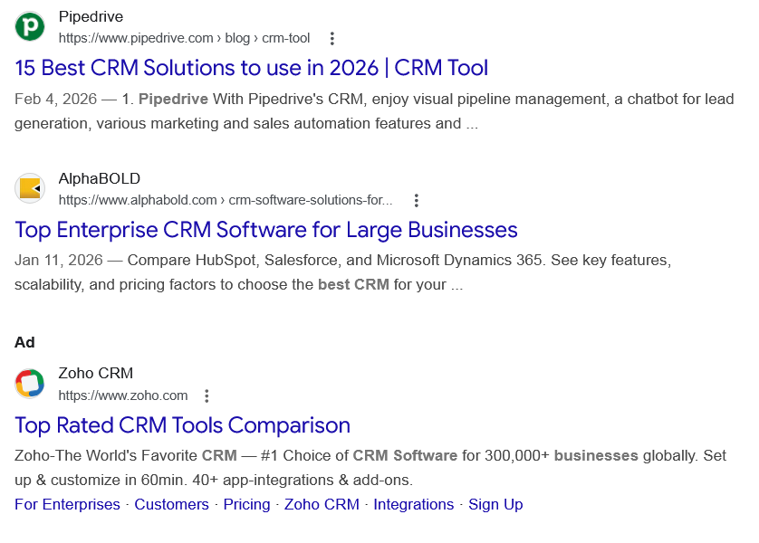
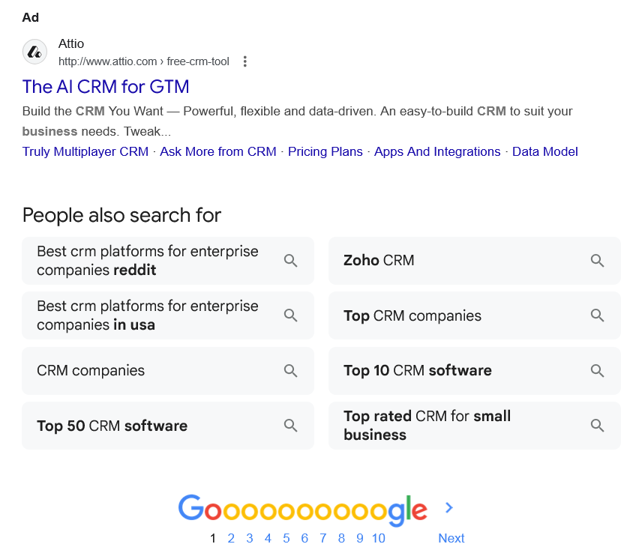
Ad

Compare Top CRM Platforms
Zoho CRM
https://www.zoho.com

Zoho CRM
https://www.zoho.com

My Ad Centre
Zoho-The World's Favorite CRM — #1 Choice of CRM Software for 300,000+ businesses globally.

For Enterprises
Scale and grow your Enterprise with Zoho CRM

Customers
Over 300,000 businesses trust Zoho CRM

Pricing
Transparent prices. Flexible contracts.

Integrations
Connect with 1100+ apps seamlessly. Zoho CRM + your favorite apps

Sign Up
Get started with your 15-day free trial

People also search for
Ad

The AI CRM for GTM | Consider Attio | Best CRM Tool
Attio
http://www.attio.com › free-crm-tool

Attio
http://www.attio.com › free-crm-tool

My Ad Centre
Powerful, flexible and data-driven. An easy-to-build CRM to suit your business needs. Tweak...

People also search for
Ad

AWS for Software & Technology - Reduce Operational Costs
Amazon Web Services
https://aws.amazon.com › aws › isv

Amazon Web Services
https://aws.amazon.com › aws › isv

My Ad Centre
Scale Your Business With Enterprise-Grade Infrastructure and Support from 140K+ Partners. Build...

People also search for

Web results

Best Enterprise CRM Software in 2026

G2
https://www.g2.com › ... › CRM Software for Enterprise

G2
https://www.g2.com › ... › CRM Software for Enterprise
We match buyers to the right Enterprise Business CRM to fit their needs. Compare product ratings based on reviews from enterprise users.

20 Best CRM Enterprise Software Reviewed For 2026

The CRO Club
https://croclub.com › Tools

The CRO Club
https://croclub.com › Tools
Jan 13, 2026 — Discover the best CRM enterprise software for your team. Compare features, pros + cons, pricing, and more in my complete guide.
Discussions and forums

best crm for small businesses, honest opinions and real user experiences
Reddit ·
r/Entrepreneur
· 30+ comments
· 1 month ago

best crm for small businesses, honest opinions and real user experiences
Reddit ·
r/Entrepreneur
· 30+ comments
· 1 month ago
reporting feels clunky too, like i have to jump through hoops just to pull basic pipeline data from a customer relationship management tool. More

What's the best CRM for new online businesses? And why?
Quora ·
1 answer
· 1 year ago

What's the best CRM for new online businesses? And why?
Quora ·
1 answer
· 1 year ago
The best CRM is the one your team loves using the most. Get your team together, map out your ... More
Top answer · 184 votes · 9 years ago
What do you need from your CRM & what problems you want it to solve? 1. What are your ... More
61 votes · 7 years ago
I've tried the following CRM's: 1. Elastic (Close.io [ http://close.io/ ]) 2. Nimble ... More
41 votes · 12 years ago

What are the best CRM options for startups?
Quora ·
2 answers
· 1 year ago

What are the best CRM options for startups?
Quora ·
2 answers
· 1 year ago
The best CRM is the one your team loves using the most. Get your team together, map out your ... More
Top answer · 184 votes · 9 years ago
What do you need from your CRM & what problems you want it to solve? 1. What are your ... More
61 votes · 7 years ago
I've tried the following CRM's: 1. Elastic (Close.io [ http://close.io/ ]) 2. Nimble ... More
41 votes · 12 years ago

See more

Web results

What are your best CRM recommendations for enterprise ...

Reddit · r/CRM
20+ comments · 1 year ago

Reddit · r/CRM
20+ comments · 1 year ago
Any CRM linked to an ERP is usually not the best. For your first 3 requirements you can check out Salesflare. And for SEO I recommend Ahrefs.
20 answers · Top answer: For a system that covers both CRM and MRP/ERP functionalities, HubSpot with an integration ...
What's the best CRM you're using right now and ...
173 answers
Oct 7, 2025
What's the Best CRM for Software Companies? : r ...
9 answers
Sep 24, 2024
More results from www.reddit.com

Enterprise Guide and Top 12 Enterprise CRM Solutions

Lark
https://www.larksuite.com › en_us › blog › enterprise-c...

Lark
https://www.larksuite.com › en_us › blog › enterprise-c...
Dec 15, 2025 — 1. Lark: The collaborative workspace for enterprise CRM · 2. Salesforce: The highly customizable and scalable enterprise CRM platform · 3. HubSpot ...

CRM For Service Businesses: 6 Best Solutions For 2026

Monday.com
https://monday.com › Home › CRM and sales

Monday.com
https://monday.com › Home › CRM and sales
Jan 5, 2026 — The 6 best CRMs for service businesses · 1. monday CRM · 2. HubSpot Smart CRM · 3. Zoho CRM · 4. Salesforce Sales Cloud · 5. Creatio CRM · 6.
•
monday CRM

•
HubSpot Smart CRM

•
Zoho CRM

•
Salesforce Sales Cloud

People also ask
What CRM does Enterprise use?
Why Trust Our Software Reviews
 | Tool | Best For
3 | Salesforce CRM | Best customizable solutions for enterprises
4 | Salesflare | Best for B2B sales
5 | Zoho CRM | Best for scaling process automation
6 | Microsoft Dynamics 365 | Best for teams using Microsoft products
6 more rows
•
Jan 13, 2026

20 Best CRM Enterprise Software Reviewed For 2026

The CRO Club
https://croclub.com › Tools

The CRO Club
https://croclub.com › Tools
What is the best CRM for businesses?
The 6 best CRMs for service businesses
Platform | Use case | Starting price
HubSpot Smart CRM | Robust CRM with great marketing and sales tools | Free plan
Zoho CRM | User-friendly platform for building lasting customer relationships | 15 days
Salesforce Sales Cloud | Enterprise-level service CRM with tons of integrations | 30 days
3 more rows
•
Jan 5, 2026

CRM For Service Businesses: 6 Best Solutions For 2026

Monday.com
https://monday.com › Home › CRM and sales

Monday.com
https://monday.com › Home › CRM and sales
What CRM software do most companies use?
The Best CRM Software Companies for 2026
- Act! Description: The Act! ...
- Apptivo. Description: Apptivo's Customer Relationship Management solution enables its users to attract, engage, and retain more customers. ...
- Bitrix24. ...
- Copper. ...
- Creatio. ...
- Freshworks. ...
- HubSpot. ...
- Insightly.
More items...
•
Jan 5, 2026

27 of the Best CRM Software Companies to Know About for ...

solutionsreview.com
https://solutionsreview.com › crm › 2026/01/05 › best-...

solutionsreview.com
https://solutionsreview.com › crm › 2026/01/05 › best-...
What is the #1 CRM platform?
Salesforce is the #1 AI CRM and a trusted platform built to meet the needs of complex organizations. You can scale endlessly on a single, integrated platform.

The world's #1 AI CRM powers the Agentic Enterprise. - Salesforce

Salesforce
https://www.salesforce.com › crm

Salesforce
https://www.salesforce.com › crm

Web results

Enterprise CRM: Features, Best Platforms, and Selection Tips

Itransition
https://www.itransition.com › CRM services

Itransition
https://www.itransition.com › CRM services
Dec 10, 2025 — Enterprise CRM tools typically feature advanced workflow automation and data analytics capabilities to meet the needs of large companies.

What is Enterprise CRM? 14 Best Enterprise CRM Software

Creatio
https://www.creatio.com › glossary › enterprise-crm

Creatio
https://www.creatio.com › glossary › enterprise-crm
Dec 31, 2025 — Leading enterprise CRM platforms include Creatio CRM, Salesforce, Microsoft Dynamics 365, HubSpot, Zoho CRM, and Oracle CX. These systems ...
•
Key Features of Enterprise...

•
Best Enterprise CRM Software...

15 Best CRM Solutions to use in 2026 | CRM Tool

Pipedrive
https://www.pipedrive.com › blog › crm-tool

Pipedrive
https://www.pipedrive.com › blog › crm-tool
Feb 4, 2026 — 1. Pipedrive With Pipedrive's CRM, enjoy visual pipeline management, a chatbot for lead generation, various marketing and sales automation features and ...

Top Enterprise CRM Software for Large Businesses

AlphaBOLD
https://www.alphabold.com › crm-software-solutions-for...

AlphaBOLD
https://www.alphabold.com › crm-software-solutions-for...
Jan 11, 2026 — Compare HubSpot, Salesforce, and Microsoft Dynamics 365. See key features, scalability, and pricing factors to choose the best CRM for your ...
Ad

Top Rated CRM Tools Comparison
Zoho CRM
https://www.zoho.com

Zoho CRM
https://www.zoho.com

My Ad Centre
Zoho-The World's Favorite CRM — #1 Choice of CRM Software for 300,000+ businesses globally. Set up & customize in 60min. 40+ app-integrations & add-ons.
‎For Enterprises · ‎Customers · ‎Pricing · ‎Zoho CRM · ‎Integrations · ‎Sign Up
Ad

The AI CRM for GTM
Attio
http://www.attio.com › free-crm-tool

Attio
http://www.attio.com › free-crm-tool

My Ad Centre
Build the CRM You Want — Powerful, flexible and data-driven. An easy-to-build CRM to suit your business needs. Tweak...
‎Truly Multiplayer CRM · ‎Ask More from CRM · ‎Pricing Plans · ‎Apps And Integrations · ‎Data Model
People also search for

Best crm platforms for enterprise companies reddit

Best crm platforms for enterprise companies in usa

CRM companies

Top 50 CRM software

Zoho CRM

Top CRM companies

Top 10 CRM software

Top rated CRM for small business

Page navigation
 | 1 | 2 | 3 | 4 | 5 | 6 | 7 | 8 | 9 | 10 | Next

